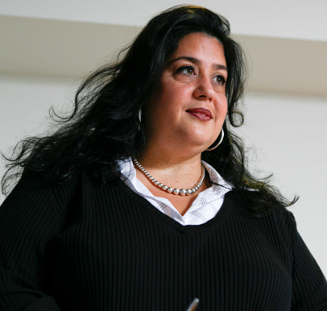

Improve your health -

***without dieting***

***Well Now***

**8 week course on xxxx mornings xxxx**

**A fun, effective course suitable for people of all sizes**

* learn to listen to your appetite and emotions
* feel more confident about yourself and your body
* explore the bigger picture of health
* ditch eating guilt to make peace with food

***This is not a slimming club!***

***YOUR DETAILS HERE:***