Session 3 Feelings, Sensations and Emotions Vocabulary
Angry  aggravated  annoyed  defiant  disgusted  enraged  exasperated  frustrated  furious  hateful  hostile  indignant  mad  obstinate  outraged  perturbed  peeved  pissed off  rebellious  seething  spiteful  surly  upset  vengeful  blood boiling  hot under the collar  Loving  affectionate  aroused  caring  devoted  intimate  tender  warm  loved  supported  appreciated  valued  respected  trusted  trusting  trustworthy | Ashamed  apologetic  embarrassed  foolish  guilty  humble  idiotic  mortified  regretful  remorseful  shameful  worthless  red faced  Confident  bold  capable  centred  eager  energetic  focused  grounded  hopeful  inspired  keen  optimistic  powerful  productive  Happy  amused  cheerful  delightful  ecstatic  elated  excited  exuberant  gleeful  high  joyful  mischievous  warm  glowing  light-hearted | Hurt  abandoned  abused  attacked  belittled  bitter  cheated  disappointed  dismayed  grieving  gypped  humiliated  let down  betrayed  mournful  sorrowful  rejected  resentful  Sad  despondent  depressed  dismal  low  melancholy  gloomy  miserable  weepy  fragile  dark mood  Confused  baffled  befuddled  bewildered  disoriented  flustered  perplexed  puzzled  scattered  troubled  flummoxed  muddled  out-of-sorts

Satisfied
adequate
content
mellow
peaceful
replete
tranquil
heartened

Scared
afraid
alarmed
fearful
frightened
horrified
hysterical
insecure
intimidated
nervous
panicky
petrified
terrified
threatened
vulnerable
dirty
dishevelled
discombobulated
neck hairs standing

Surprised
aghast
amazed
astonished
astounded
incredulous
shocked
startled
knocked for six

Uncaring
ambivalent
apathetic
bored
busy
detached
exhausted
indifferent
fake

Thankful
appreciative
grateful
gratified
indebted
obliged
relieved
content
glowing
glad
smiling inside

Thoughtful
challenged
curious
illuminated
informed
engaged
interested
pensive
reflective
eyebrows meeting

Uncertain
cynical
doubtful
dubious
distrustful
hesitant
indecisive
pessimistic
sceptical
suspicious
unsure
unsettled

Wanting
empty
envious
homesick
hungry
ignored
jealous
lonely
longing
lustful

Weak
inadequate
burdened
controlled
despairing
discouraged
helpless
hopeless
impotent
inhibited
lost
passive
powerless
restricted
trapped
suicidal

Worried
agitated
anxious
bothered
restless
tense
uneasy
unsettled
gullible

Body Talk
agitated
cold feet
spaced out
frisky
hot under the collar
butterflies in the stomach
sexy
under my skin
bright eyed
on my nerves
present
connected
…
…
…

Session 3 – To Go : ideas to continue your reflection -

Apart from eating, how else do you comfort yourself?

Do you think other people’s attitudes to you influence your eating?

How much do childhood habits, rules, behaviours influence your eating now?

If you were your own best friend overhearing your comments about your eating/weight what would you say to yourself?

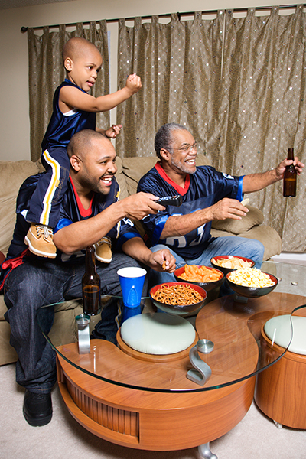
Can you finish the sentences:

One thing I’m going to do differently is …..

My strongest feeling in relation to this issue is …

It was helpful to hear …..

I was glad to have the chance to think/talk through …

Session 4 - To Go

Mind Web of my Well Now Journey So Far

Session 5 – Hydration - Print on card or address labels.

helps maintain body temperature | protects oral hygiene | improves cognitive performance
decreased risk of heart disease | falls prevention (reduces fainting) | prevents urinary tract infection
prevents constipation | prevents kidney and gall stones | healthy skin and spine
optimise sporting performance | headache | dizziness
light headedness | tiredness | weakness
sluggishness, no get up and go | increased risk of infection | impaired kidney function
damage to liver, joints, spine, muscles | constipation | decreased exercise tolerance
confusion/ difficulty concentrating | sleepiness | impaired mental performance & coordination

Session 5 – Fish is the Dish
type of eating occasion ………………………………………………….
meal idea ………………………………………………………………………

type of eating occasion ………………………………………………….
meal idea ………………………………………………………………………

type of eating occasion ………………………………………………….
meal idea …………………………………………………………………………

MEALS WITH NON-FISH SOURCES OF PRE-OMEGA 3

- .

- .

- .

- 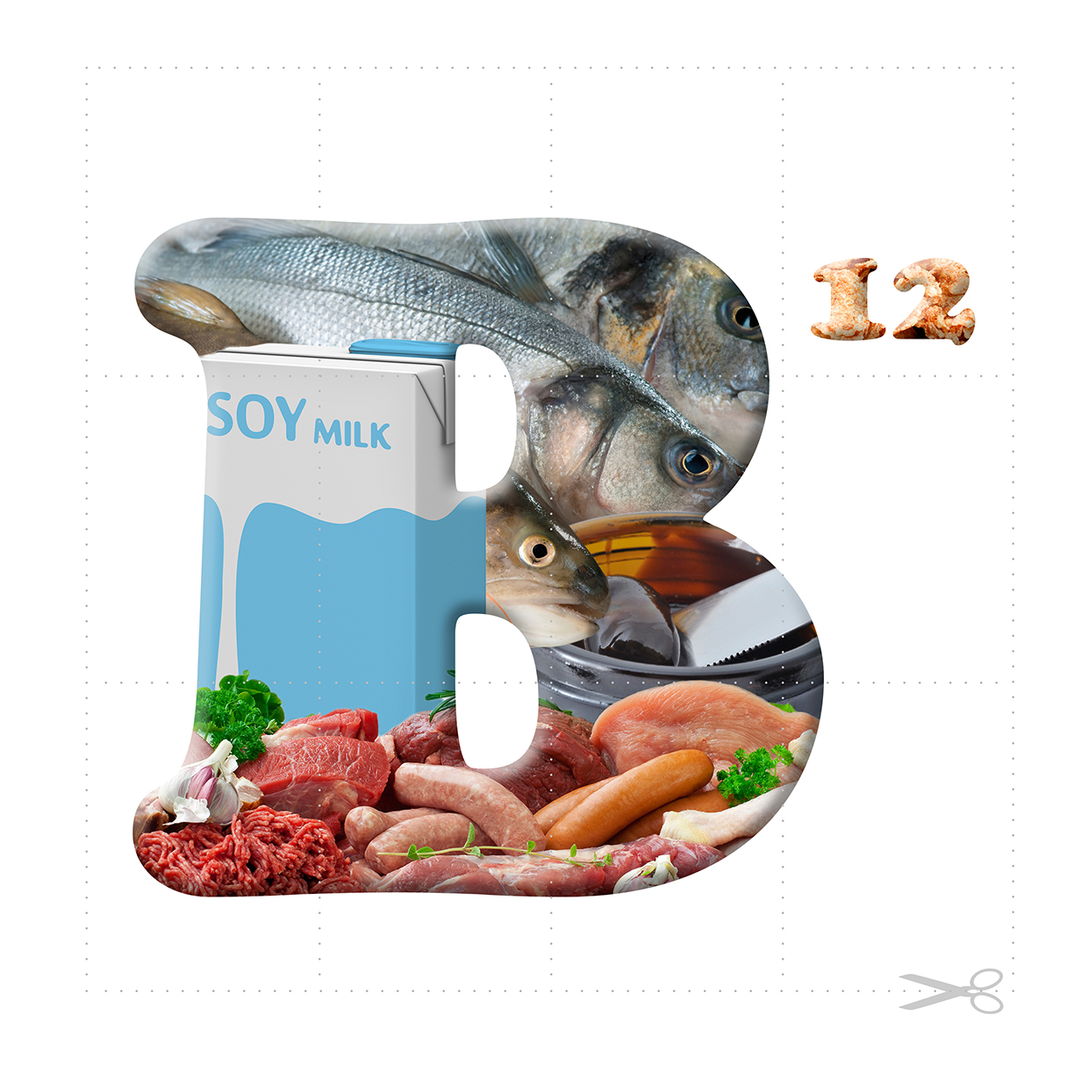

Session 5 Piecing it Together - Vitamins and Minerals
- 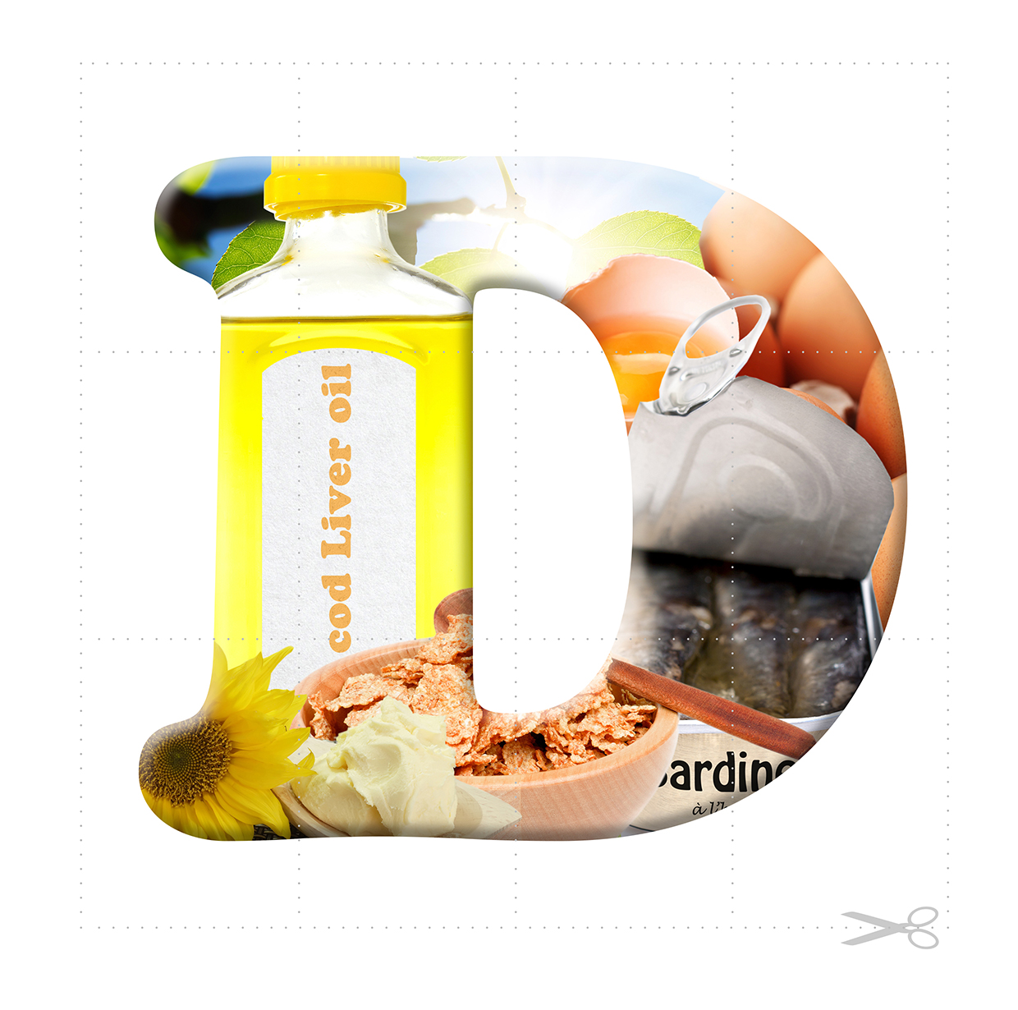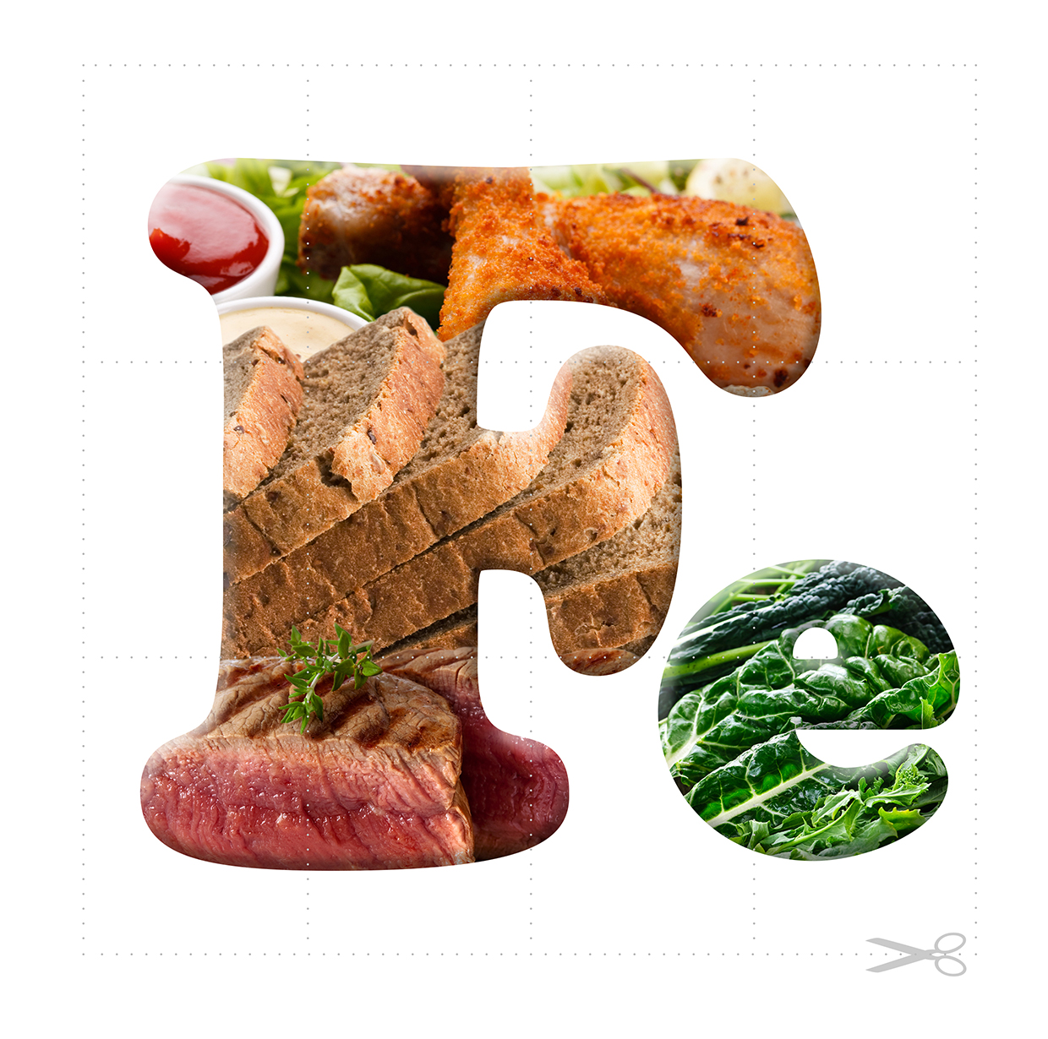

Session 5 - Beyond nutrients
The course lends itself to linguistic learners as there are so many words, words , words. We want to appeal to visual and spatial learners too. Can you find dolls to represent the matrons and a few children, and draw 2 orphanages, using this set up to illustrate the story? Alternatively you can cut out the pictures here and draw the orphanages on the flip chart paper, using blu-tac to move people around and draw in rations.

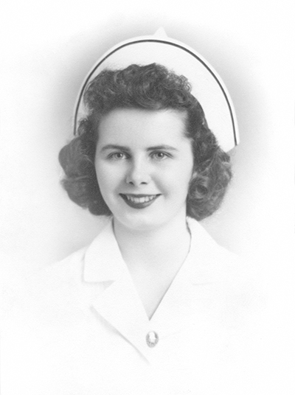
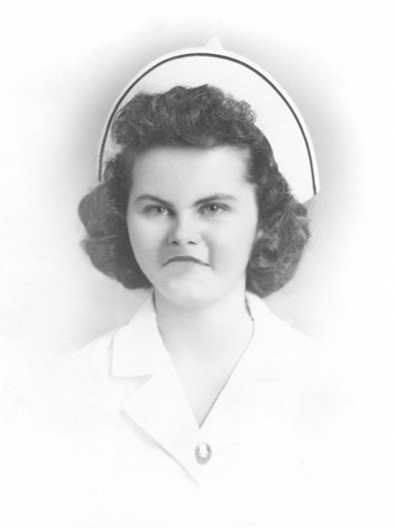

Session 5 - To Go

What considerations come towards the top of the list for you when making food choices? How does what you eat reflect what you value?

Picture a meal/eating occasion you really enjoyed. What made it so special for you? What feelings are evoked when you think back? How can you recreate some of those feelings?

Look out for nutrition messages during the week. Are there any that sound suspect to you? How does it make you feel when you hear them? What can you learn from your response?

Draw a time-line noting when you introduced new foods to your cupboard or started experimenting when eating out. Can you identify where any ‘food fashions’ influenced your eating? Perhaps it was a ‘must have’ new bread, or ‘superfood’, or you began kick-starting the day with a coffee on your way to work, or simply discovered something fantastic that you’d never tried before.
Have there been any events that have changed or disrupted your everyday eating?

Session 6 – A walk in the park

Session 6 - To Go My Picture of Health

What does your ‘picture of health’ look like?

You can get creative by cutting out images from magazines, using song lyrics, photos and so on to put together a picture that reminds you what health means to you.

How is this different from something you might have made in response to the same question before starting the Well Now course?

Alternatively, use the Jigsaw sheet (provided) to write in your ideas, or illustrate the photo frame with whatever sketches, phrases and so on that speak to you.

