Session 7

Privilege and Prejudice

- Are my children likely to be free from bullying?
- Do I feel treated as a worthwhile person rather than a drain on society?
- Can I go round the supermarket without being stared at or ridiculed?
- Are my experiences, and knowledge, generally valued and rewarded by society?

- Can I expect my health concerns to be taken seriously by the doctor?
- Does my physical presence command respect?
- Do I get represented as a valued person in TV programmes?
- Are my days mostly free from fear?

- Would I get a fair hearing in a job interview based on my qualifications?
- Would I get sympathy from my employer if I was ill?
- Do I feel the science written about me is accurate?
- Are my rights to fair treatment protected by law?
- If I am unwell do I usually get more empathy than blame?

- Could I read a book about my history and culture on a crowded train without feeling uncomfortable?
- Can I easily use public transport at rush hour?
- Am I seen as a good parent, and/or allowed to adopt?
- Can I walk down the street without harassment?

- Are there a number of positive role models of people like me (on TV/in the school curriculum/in health literature)?
- Do I feel safe being out alone after dark?
- Are my comments and opinions usually treated as valuable by others?
- Can I readily get life insurance?
- Can I use public toilets without risk of critical comment?

- If I went on a TV talent show would the presenters treat me respectfully on the basis of my appearance?
- Could I comfortably hold hands with or kiss a partner in public?
- Are my family supportive of me as I am?
- Could I eat out without feeling uncomfortable, or worrying about attracting unwanted attention?

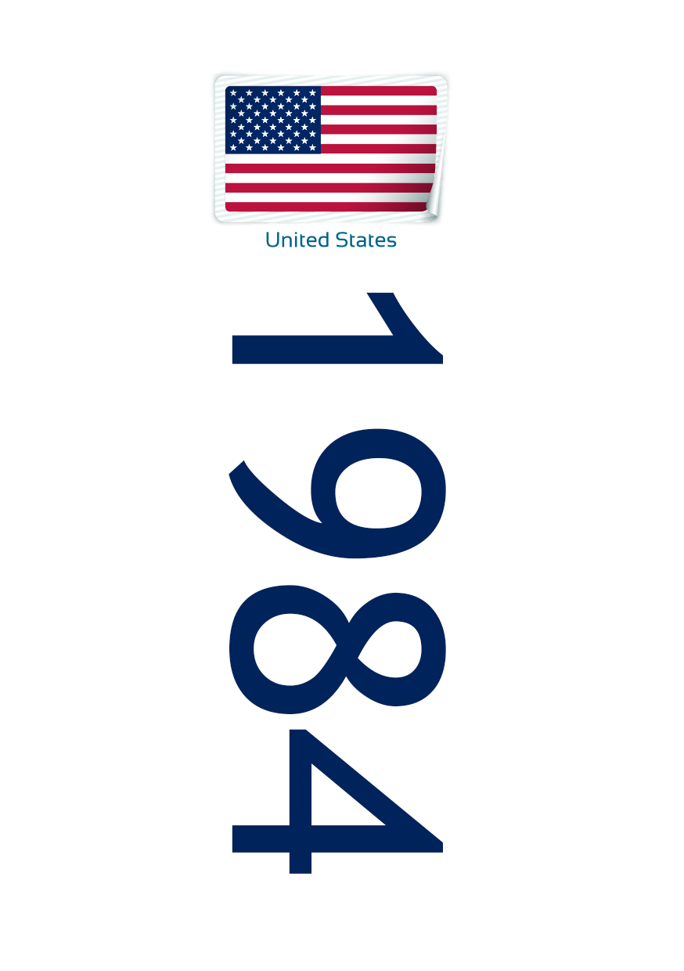

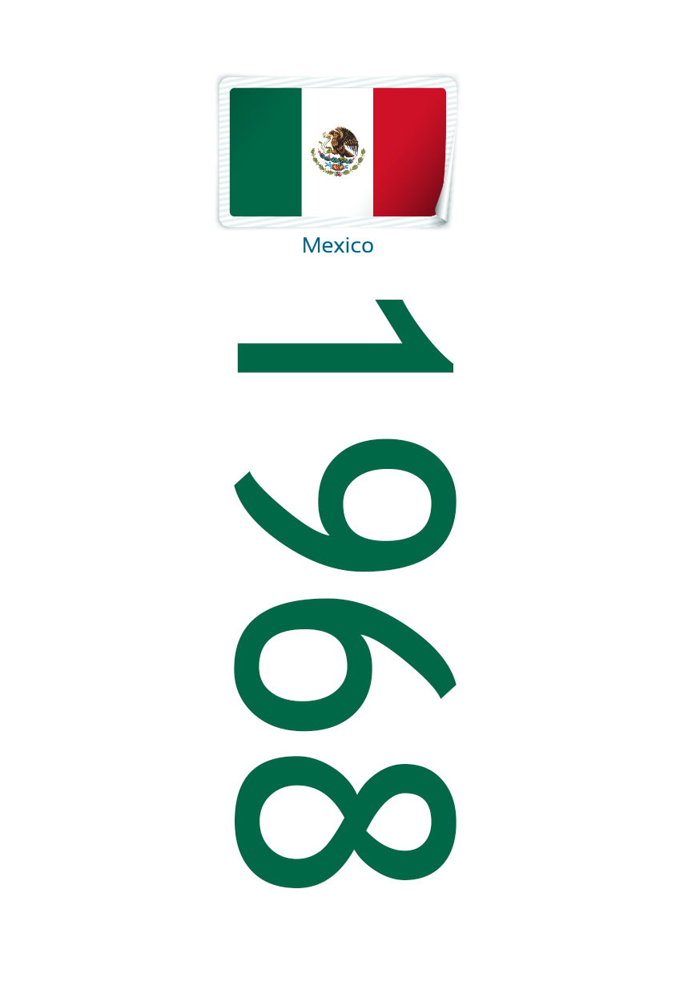

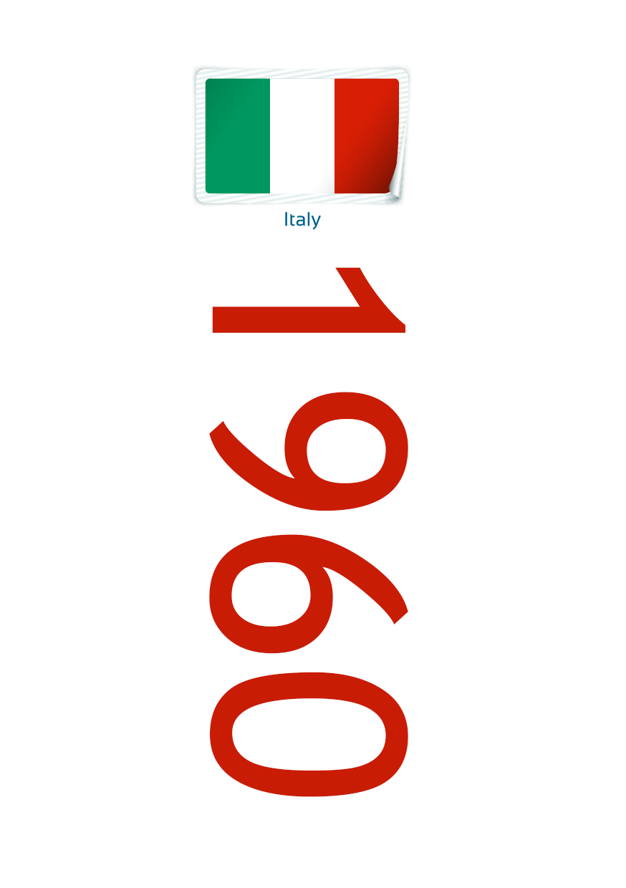

Session 7

Collect pictures from magazines and other media and mount them on card.

- Include diversity by:
* Size * Ethnicity * Age * Social standing * Disability * Gender * Other axes

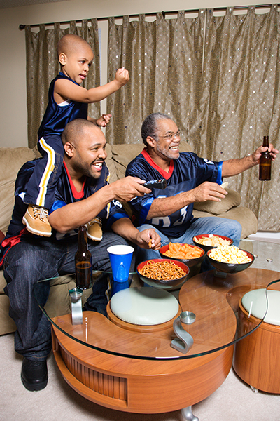
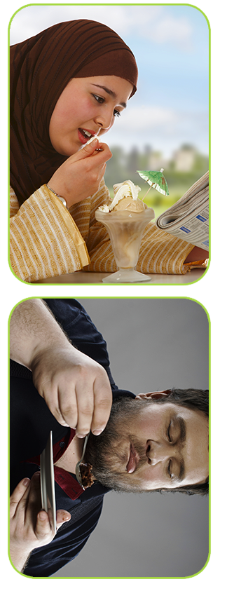
Create a character and imagine their story

Letter to Family & Friends

Dear xx

I am writing to you because I know that my weight and health are important to you. I recognise that you have tried hard to support me in making changes over the years and I appreciate your kind intentions.

As you know, I’ve been struggling with my eating, and how I feel about myself, for a long time. At last, I have found something that is helpful. I am so relieved. After all the terrible years spent on and off diets I now have an alternative.

I’m using an approach called the Well Now way. It’s written by a dietitian and is being delivered by the NHS. It works by switching away from a single-minded focus on weight-loss and focuses on health-gain and body respect instead.

I’m pleased how the changes I’ve made have improved things for me already. I’ve learnt that I can be healthier and happier and more confident without knowing if my weight is changing. That’s such a huge improvement for me. A key point is that when people value themselves they are more likely to take care of themselves and that has certainly been true in my case. The biggest challenge has been learning to value myself in a world that tells us our worth is down to our looks or our health. [This is especially tough for me as a fat person]. In fact, of course, every body is worthy of respect and when I remind myself of this it helps me look after myself.

If you’d like to know more I’d be happy to share what I am learning. Meanwhile, the best way you can support me now is by not commenting on my weight, health, eating or activity. This leaves room for us to talk about so much more.

Warmest wishes

xxxxxxx

Letter to GP

Dear Dr xx

I am writing to let you know about a healthy weight course I am doing. The course is called Well Now. It is written by a dietitian and is being delivered in the NHS. It works by shifting the focus from weight-loss to support health-gain and body respect for all. I know you are concerned about my health because of my weight and that you have tried to encourage me as best you can. For this reason, it feels important to mention the Well Now approach to you in case you have not yet come across it elsewhere.

As you may know, I have been on and off diets for years. This means I have been very preoccupied with food. It has been hard to exercise in part due to low body confidence. The Well Now approach has reduced my difficulties with food and improved my confidence. What is different is that it teaches us to focus on improving diet, activity and self-esteem as ends in themselves. This makes it possible to stick with lifestyle improvements regardless of how much weight is or isn’t lost. It has been a revelation for me how this change of emphasis could be so empowering. I am also learning mindfulness.

It would help me stick with the changes I am making if we could move away from using weight as an independent health indicator in our consultations. I do understand weight and health can be linked. What I am asking is that we focus on my health condition itself rather than my weight. An example in the Well Now course that helped make this difference clear for me is when we looked at how changing dietary quality, activity, mindfulness and respect can all impact weight-related conditions (like blood pressure or diabetes) even if someone’s weight stays the same. The Well Now way isn’t against weight loss. It recognises that someone’s weight may reduce as a result of lifestyle changes. It also recognises that not everyone will lose weight and that keeping the focus on health-gain and body respect helps people stick with changes independent of weight loss. This encourages behaviour change and avoids the cycles of despair and self-loathing that accompany yo-yo dieting. I have certainly found this to be true for me.

In case you would like to satisfy yourself that the Well Now course is evidence based, and effective, there is information on this website: www.lucyaphramor.com

Thank you for reading.

Kind regards

xxxxxx

Session 7 – Critical Thinking Questions

Consider language (vocabulary/tone) and images:

- Does it use sensational language? Does the language legitimize (support) discrimination, depersonalize (present people as less than human), pathologise (treat people as if there is something wrong with them, medically or otherwise) or insult people?

- Are the images respectful of fat people?

- Does it judge people’s worth or deservingness on the basis of their health or size or physical activity levels?

- Is it moralizing?

- What claims are made about BMI and health? Are these accurate?

- What claims are made for the health benefits of weight loss? Are these scientific?

- What claims does it make about effectiveness of dieting? Are these accurate?

- Does it mislead by silence or confusion? Eg. Does it talk about unfavourable effects of dieting; or how respect impacts wellbeing?

- Is it likely to encourage the reader to look after themselves? Or to respect themselves and others?

- What impact is likely on the reader’s emotional state – acceptance, body satisfaction, guilt, anxiety, self-efficacy, self-trust, shame etc? And their relationship with food and their bodies?

- Is it written from a compassionate standpoint?

- What impression are you left with about fat people, thin people, weight and health, health and lifestyle, health and social factors?

- Do the writers take opportunity to actively challenge size stereotype and poor science?

- Does it mention the impact of respect on health outcomes?

- What are the author’s conflict of interest? Do they declare their biases?

Session 7

Material on air brushing, such as before and after photos of celebrities eg. downloadable from :

http://www.mediasmart.org.uk/docs/bodyimage/Teachers_Notes.pdf

Session 7 - Keeping In Touch

This form is for anyone who would like to keep in touch with other members of this Well Now course once it ends.

Please give contact details you are happy to share. I will then ask a volunteer to collate the information and distribute it to those wishing to keep in touch.

Name:

Telephone Number:

Email:

Area you live in:

Other Info:

If you have any ideas for activities you’d be interested in doing that would help you and others put Well Now into practice, including simply having fun or developing your Well Now imagination, please list them here:

Session 7 – A Map of my Well Now Journey So Far

Session 7 – To Go

The most exciting thing for me about Well Now is

The most challenging thing for me about Well Now is

To help me to remember the things that I found most helpful in the Well Now course I will

Because I speak more kindly to myself I have noticed

(Thinking about) practicing self-care over the last few weeks has helped

Session 8 - Size Acceptance Slinky
Print out the 5 words and attach them around a slinky in the order they appear here.

Denial

Anger

Bargaining

Depression

Acceptance

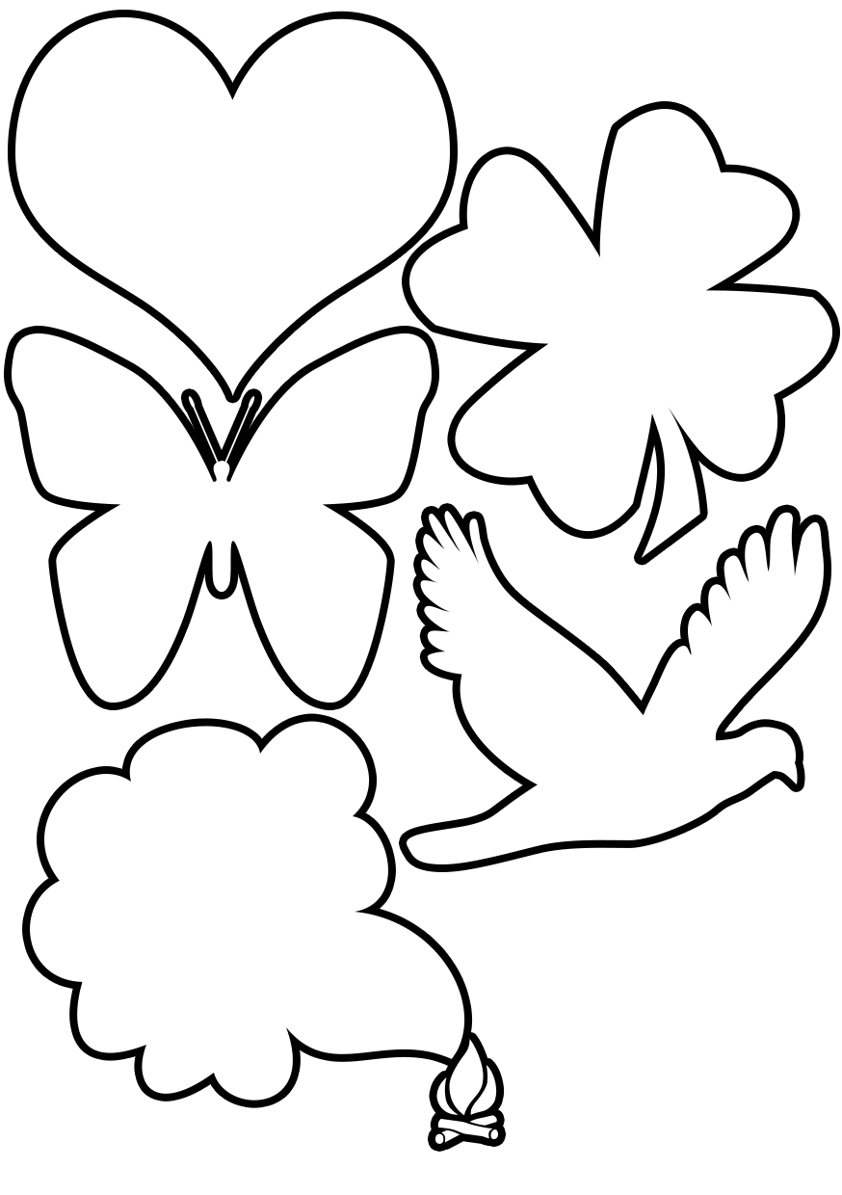

Session 8 Peace in our body

Session 8 Building Community

(Well Now is unusual for exploring body respect (rather than body image) and looking at the bigger picture of wellbeing. Many of these suggestions focus in on body image, but you may still find them useful).

These links are all from Twitter.

https://twitter.com/#!/TrappedMeCurvy

http://www.campaignforbodyconfidence.org.uk/

https://twitter.com/#!/slinkmagazine

http://www.fatnutritionist.com/

https://twitter.com/#!/BeautifulMagUK

https://twitter.com/#!/EvolveOnlineMag

https://twitter.com/#!/VagendaMagazine

https://twitter.com/#!/fatandtheivy

https://twitter.com/#!/NevrDietAgnUK

https://twitter.com/#!/definatalie

https://twitter.com/#!/Fatheffalump

http://danceswithfat.wordpress.com/blog/
Here are a few plus size fashion blogs which are really great.

http://archedeyebrow.com/

http://www.pocketrocketfashion.com/

http://theramblingsofmrsbebe.blogspot.co.uk/

http://theplussideofme.com/

http://garnerstyle.blogspot.co.uk/

http://amonkeyfatshionista.wordpress.com/

http://diamonds-n-pearls-fat-girl.blogspot.co.uk/

http://fattyunbound.blogspot.co.uk/

http://thewardrobechallenge.co.uk/
http://obesitytimebomb.blogspot.co.uk/
Superb blog by Charlotte Cooper, UK

“Jenny sends a weekly email that lands in your inbox on a Monday morning. Full of positive thoughts. It’s quite a way to start the week!” http://www.fuckthediets.com/home/

Here are some links from Facebook:

https://www.facebook.com/home.php#!/fitfabulous.supporting.health.positive.bodyimage

https://www.facebook.com/home.php#!/FatTalkFree

https://www.facebook.com/home.php#!/AdiosBarbie

HAES Community
www.sizediversityandhealth.org

Fat Rights Groups
www.NAAFA.org
National Association to Advance Fat Acceptance, US
www.cswd.org
Council on Size & Weight Discrimination, US
www.allegrofortissimo.com
French fat rights group
http://groups.yahoo.com/group/fatstudies
Forum for an academic take on fat

www.fatso.com
US fat activist Marilyn Wann’s site

www.obesitymyths.com
Critical weight science

Related sites:
www.jonrobison.net
www.healthyweight.net
www.nourishingconnections.com
www.bodypositive.com
Books
www.pearlsong.com
Plenty of fat positive fiction to choose from here
Susan Stinson has fabulous fat characters
www.susanstinson.net

The Fat Studies Reader
http://www.amazon.com/Fat-Studies-Reader-Esther-Rothblum/dp/0814776310
The Obesity Myth: Why America's Obsession with Weight Is Hazardous to Your Health,
Paul Campos. A critical look at weight.
Taking Up Space, Pattie Thomas
A memoir about being fat.

Non-toxic films with fat characters
Hairspray (1988)
Bagdad Café (1987)
… can anyone help out with some more?

Session 8 - To Go
What strengths and skills have you discovered? How will you continue to grow your ‘Well Now imagination’ in the following areas?

Wellbeing

Enjoyment

Activity

Respect

Eating

Other ideas

Kindfulness

Are there any topics you want to find out more about? List them here. What is it about them that intrigues or challenges you or feels important?

How would you describe the Well Now course to a (dieting) friend who is curious about attending? Would you recommend it?

End notes ….

