Writing Prompts 3

1. Painting with Words

For this exercise, if you can spend 10 minutes outside in contact with the wild in some way e.g. a tree, weeds, the sky, the wind and so on, that would be great. When you get home (or choose something at home if you didn’t go out), picture the colour of something you have seen. Now write about this colour without using the name of the colour.

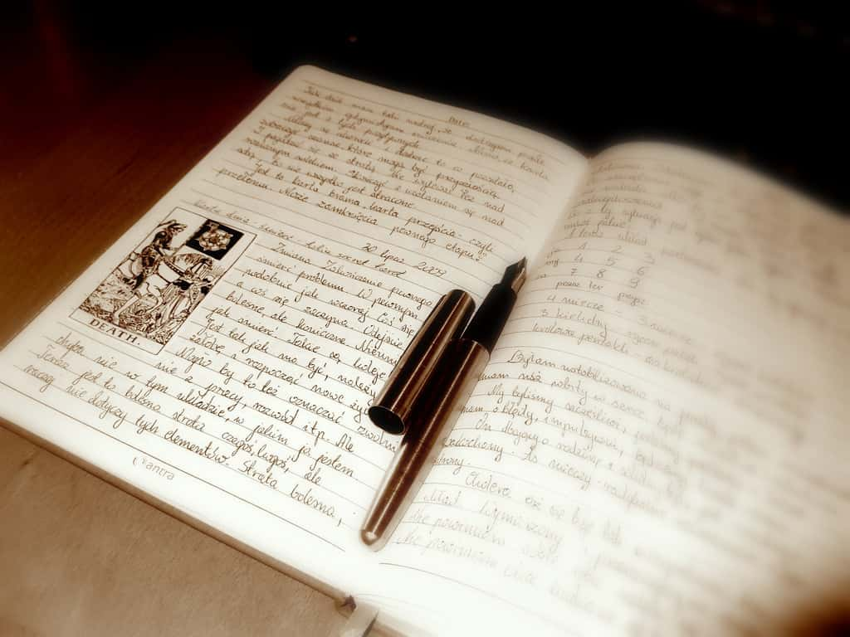

2. Drink

If you were a drink, what would you be?

You can try this for particular aspects of you who are.
For example, what sort of drink are you as a writer,
as a friend, as a parent/sibling/adult child/cousin etc.,
as a learner.

3. The Feeling of Hands

Clap your hands* together, you might find you fall into a rhythm, you might not. Whatever happens is the right thing for you! After a while stop clapping. Focus on the feelings and sensations in your hands. They might be tingling, warm, smooth etc. Staying safe, choose one of these feelings to write about, imagine it flows further into your body, or out from your body. Where does this movement take you? Repeat this with some of the other words if you like.
(*Not everyone can do this. As with every suggestion, can you use it to prompt something useful to you?).

4. Safe as . . .

What does it feel like to be safe? Write a quick list of things that come to mind.
Then go over them, which of these are characteristics of feeling safe in your body, which are to do with being safe in your environment and the outside world? Write a paragraph/poem (or doodle, or dance etc if you like!) from the perspective of somebody who is experiencing a feeling of deep safety for the first time.

5. How does the sentence continue –

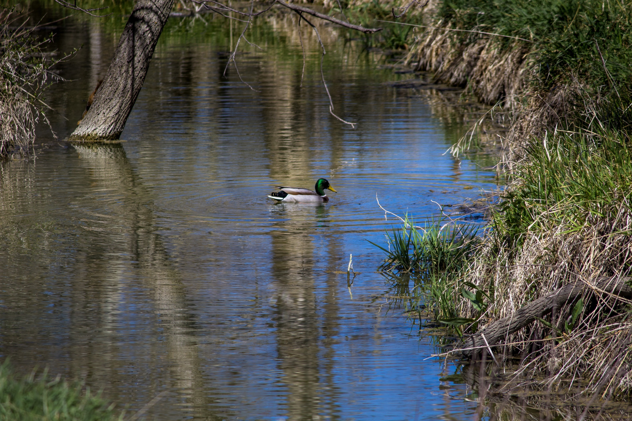
(This could be about anything, from why a cake didn’t rise, why your bike chain came off again, or something that is troubling you in your life).
I feel so confused about this and I wish I could figure it out. The thing is . . .

6. First Day Recall

Recall a time when you felt that where you were marked a significant shift in who you were becoming. For example, a first day at a job/university/school/new group/new home/new country/sports club/night club etc.

What can you remember? Why did it seem significant? Who was around? Try writing a short piece of fiction using memory as a starting place for being creative with an invented character.

7. Surviving Silence

Think of a time when you weren’t able to express yourself. This could be because it wasn’t safe to speak, or you couldn’t make sense of what was happening, or it was impossible to name your feelings, or you felt ‘tongue tied’ and physically couldn’t speak, or anything else. Imagine you are speaking to that person, what do you want them to know?
Imagine that you, as you are now, are speaking as that person. What would they/you say?

A Body Aware Practice to Try

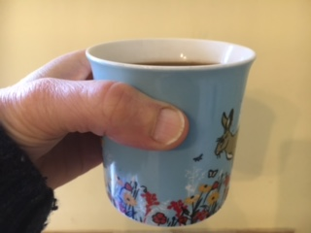
What’s your everyday drink? Water? Tea? Coffee? Kombucha? Whatever it is, when you have your first drink of the day, try taking 30 seconds to tune into the sensory connections…. e.g. the weight of the mug, the texture of the mug sides on your palms, the temperature, any aroma. If a thought drifts in that’s fine. Let it stay if, just try not to engage with it and keep your attention on the full-bodied drink commentary. On which note, if you can speak your experience aloud that’s great because it helps strengthen links between different areas of our brain.

